Linear Functions
In mathematics a function is used to relate one variable to another variable.
Suppose we consider the relationship between calorie burnage and average pulse. It is reasonable to assume that, in general, the calorie burnage will change as the average pulse changes - we say that the calorie burnage depends upon the average pulse.
calorie burnage depends upon the average pulse->calorie burnage is the dependent variable
average pulse is the independent variable.
The relationship between a dependent and an independent variable expressed mathematically using a formula (function).
A linear function has one independent variable (x) and one dependent variable (y), and has the following form:
y = f(x) = ax + b
This function is used to calculate a value for the dependent variable when we choose a value for the independent variable.
Explanation:
- f(x) = the output (the dependant variable)
- x = the input (the independant variable)
- a = slope = is the coefficient of the independent variable. It gives the rate of change of the dependent variable
- b = intercept = is the value of the dependent variable when x = 0. It is also the point where the diagonal line crosses the vertical axis.

Linear Function with one variable for prediction
Let us say we want to predict calorie burnage using average pulse.
f(x) = 2x + 80
- f(x) = The output.-predicted value of Calorie_Burnage
- x = The input, which is Average_Pulse
- 2 = Slope = how much Calorie_Burnage increases if Average_Pulse increases by one. It tells us how "steep" the diagonal line is
- 80 = Intercept = A fixed value. It is the value of the dependent variable when x = 0

The Linear function will be a straight line. The line may be a slope upwards, downwards or in some cases horizontal or vertical.
Here is a graphical representation of the mathematical function above:
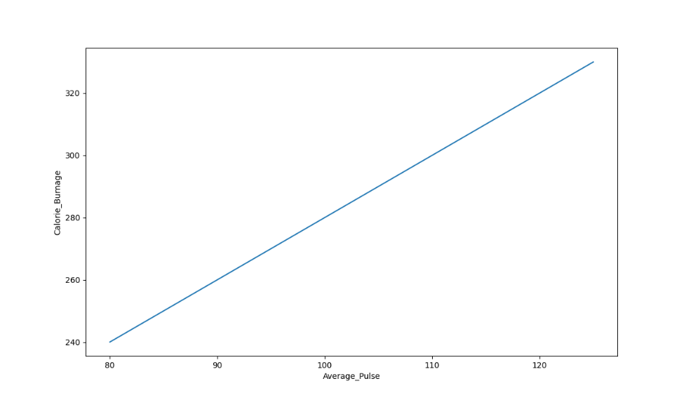
- Calorie_Burnage is a function of Average_Pulse, because Calorie_Burnage is assumed to be dependent on Average_Pulse.
- In other words, we use Average_Pulse to predict Calorie_Burnage.
- The blue (diagonal) line represents the structure of the mathematical function that predicts calorie burnage.

The Sports Watch Data Set
Take a look at our health data set:
Duration | Average_Pulse | Max_Pulse | Calorie_Burnage | Hours_Work | Hours_Sleep
30 | 80 | 120 | 240 | 10 | 7
30 | 85 | 120 | 250 | 10 | 7
45 | 90 | 130 | 260 | 8 | 7
45 | 95 | 130 | 270 | 8 | 7
45 | 100 | 140 | 280 | 0 | 7
60 | 105 | 140 | 290 | 7 | 8
60 | 110 | 145 | 300 | 7 | 8
60 | 115 | 145 | 310 | 8 | 8
75 | 120 | 150 | 320 | 0 | 8
75 | 125 | 150 | 330 | 8 | 8

Using Python
The plot() function is used to make a 2D hexagonal binning plot of points x,y:
import matplotlib.pyplot as plt
health_data.plot(x ='Average_Pulse', y='Calorie_Burnage', kind='line'),
plt.ylim(ymin=0)
plt.xlim(xmin=0)
plt.show()
The code will produce the following result:
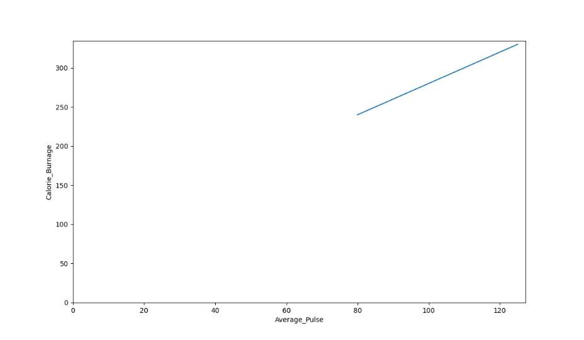
There is a relationship between Average_Pulse and Calorie_Burnage. Calorie_Burnage increases proportionally with Average_Pulse. So we can use Average_Pulse to predict Calorie_Burnage.
The line is not fully drawn to the y-axis as there are not any observations where Average_Pulse or Calorie_Burnage are equal to zero. 80 is the first observation of Average_Pulse and 240 is the first observation of Calorie_Burnage.
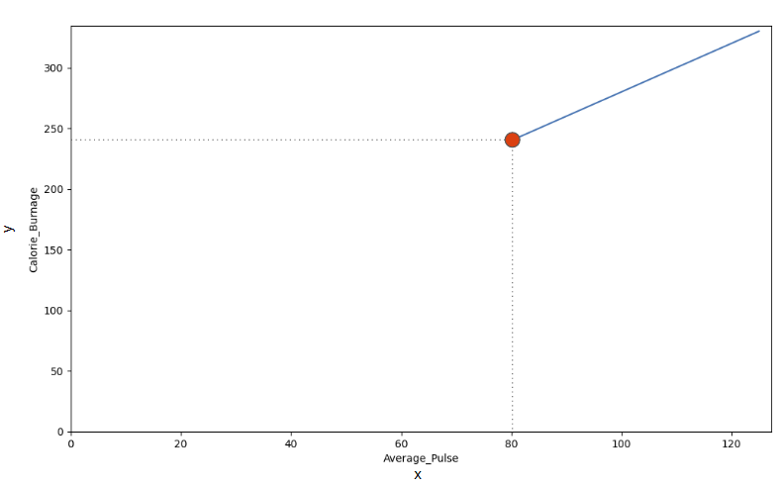
Now, What happens to calorie burnage if average pulse increases from 80 to 90?
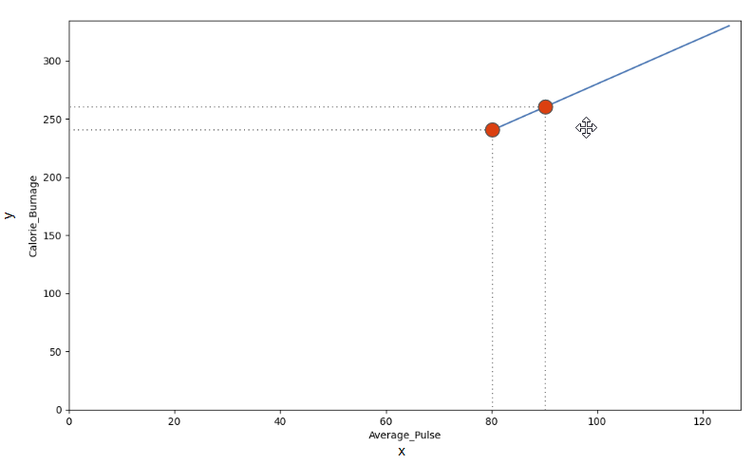
Use the diagonal line to find the mathematical function to predict calorie burnage.
So it looks like:
- If the average pulse is 80, the calorie burnage is 240
- If the average pulse is 90, the calorie burnage is 260
- If the average pulse is 100, the calorie burnage is 280
So there is pattern. If average pulse increases by 10, the calorie burnage increases by 20.

Slope and Intercept
f(x) = 2x + 80
Slope - which indicates how steep the line is, and the Intercept - which is the value of y, when x = 0
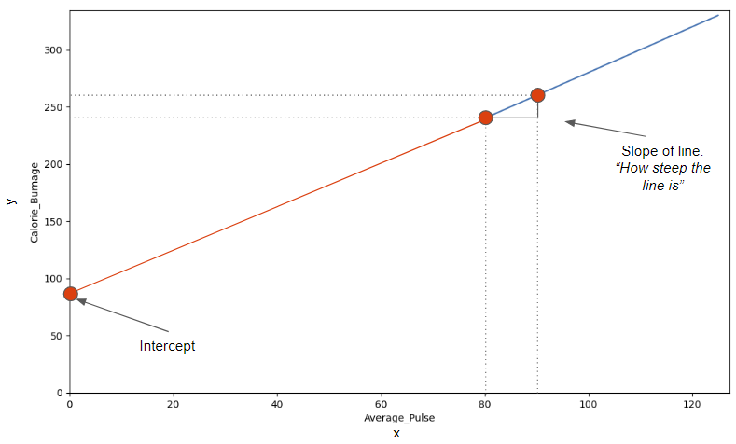
We see that if average pulse increases with 10, the calorie burnage increases by 20.
Slope = 20/10 = 2
The slope is 2.

Mathematically, Slope is Defined as:
Slope = f(x2) - f(x1) / x2-x1
f(x2) = Second observation of Calorie_Burnage = 260
f(x1) = First observation of Calorie_Burnage = 240
x2 = Second observation of Average_Pulse = 90
x1 = First observation of Average_Pulse = 80
Slope = (260-240) / (90 - 80) = 2

Using Python
Calculate the slope with the following code:

Example
def slope(x1, y1, x2, y2):
s = (y2-y1)/(x2-x1)
return s
print (slope(80,240,90,260))
The intercept is where the diagonal line crosses the y-axis, if it were fully drawn.
The intercept is the value of y, when x = 0.
Here, we see that if average pulse (x) is zero, then the calorie burnage (y) is 80.
So, the intercept is 80.

Find the Slope and Intercept Using Python
The np.polyfit() function returns the slope and intercept.
If we proceed with the following code, we can both get the slope and intercept from the function.

Example
import pandas as pd
import numpy as np
health_data = pd.read_csv("data.csv", header=0, sep=",")
x = health_data["Average_Pulse"]
y = health_data["Calorie_Burnage"]
slope_intercept = np.polyfit(x,y,1)
print(slope_intercept)

The last parameter of the function specifies the degree of the function, which in this case is "1". That means that all coefficients (the numbers) are in the power of one.
We have now calculated the slope (2) and the intercept (80). We can write the mathematical function as follow:
Predict Calorie_Burnage by using a mathematical expression:
f(x) = 2x + 80

Task:
Now, we want to predict calorie burnage if average pulse is 135.
Remember that the intercept is a constant. A constant is a number that does not change.
We can now substitute the input x with 135:
f(135) = 2 * 135 + 80 = 350
If average pulse is 135, the calorie burnage is 350.
def my_function(x):
return 2*x + 80
print (my_function(135))

Plot a New Graph in Python
Here, we plot the same graph as earlier, but formatted the axis a little bit.
Max value of the y-axis is now 400 and for x-axis is 150:

Example
import matplotlib.pyplot as plt
health_data.plot(x ='Average_Pulse', y='Calorie_Burnage', kind='line'),
plt.ylim(ymin=0, ymax=400)
plt.xlim(xmin=0, xmax=150)
plt.show()
- plt.ylim() and plt.xlim() tells us what value we want the axis to start and stop on.

Linear Regression
The term regression is used when you try to find the relationship between variables.
In Machine Learning and in statistical modeling, that relationship is used to predict the outcome of events.
In this module, we will cover the following questions:
- Can we conclude that Average_Pulse and Duration are related to Calorie_Burnage?
- Can we use Average_Pulse and Duration to predict Calorie_Burnage?

Least Square Method
Linear regression uses the least square method.
The concept is to draw a line through all the plotted data points. The line is positioned in a way that it minimizes the distance to all of the data points.
The distance is called "residuals" or "errors".
The red dashed lines represents the distance from the data points to the drawn mathematical function.
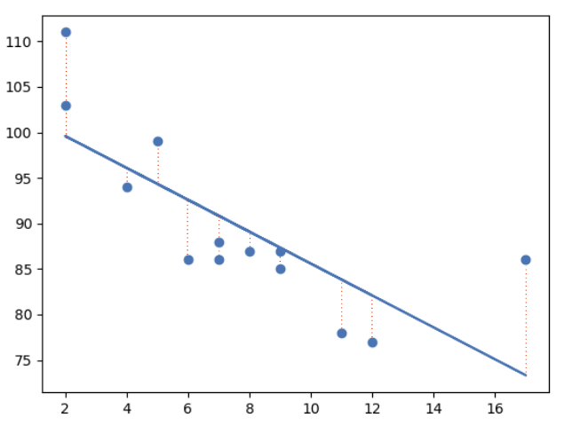

Linear Regression Using One Explanatory Variable
To predict Calorie_Burnage with Average_Pulse using Linear Regression:

Example
import pandas as pd
import matplotlib.pyplot as plt
from scipy import stats
full_health_data = pd.read_csv("data.csv", header=0, sep=",")
x = full_health_data["Average_Pulse"]
y = full_health_data ["Calorie_Burnage"]
slope, intercept, r, p, std_err = stats.linregress(x, y)
def myfunc(x):
return slope * x + intercept
mymodel = list(map(myfunc, x))
plt.scatter(x, y)
plt.plot(x, slope * x + intercept)
plt.ylim(ymin=0, ymax=2000)
plt.xlim(xmin=0, xmax=200)
plt.xlabel("Average_Pulse")
plt.ylabel ("Calorie_Burnage")
plt.show()

Output:
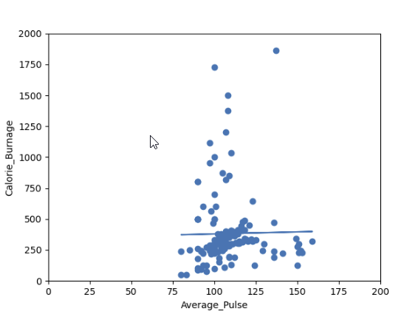

Do you think that the line is able to predict Calorie_Burnage precisely?
We will show that the variable Average_Pulse alone is not enough to make precise prediction of Calorie_Burnage.

Reference: https://www.w3schools.com/datascience/ds_linear_functions.asp

